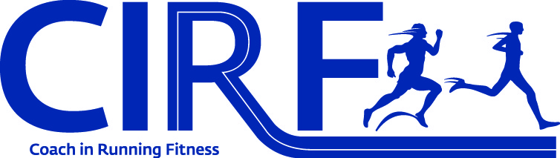

Coach in Running Fitness
Homework Pack
January 2016



ATHLETE PROFILE
Assessment of Athlete's Capabilities
You need to observe the athlete undertaking activities across running for speed, endurance, uphill, downhill, over obstacles, components of fitness and fundamental movement skill identifying their strengths and weakness / matches and mismatches in each area.
Using the skills of observation and analysis and the key technical points covered on course or from the Athletics 365 matrix, you should identify the technical matches and mismatches or monitoring test and the outcome for each area.
REMEMBER TO DESCRIBE WHAT IS A MATCH OR A MISMATCH.
Fundamental Movement Skills
What is your assessment of the athlete's fundamental movement skills and what has led you to this conclusion? The Athletics 365 development matrix may help you to answer this question. For each fundamental movement skill (agility, balance and coordination) record an activity that you have used to assess it and describe what you saw the athlete do. What are your conclusions about their skills after having observed the athlete complete the activity?
Fundamental Movement Skills Assessment
 | What activity you have used to assess this? | What did you see the athlete do? What can you conclude about this skill?
Agility | IIIinois agility test. | The athlete can perform the test in less than average time. Movement is fluid an smooth. (6/10)
Balance
Coordination | Reverse arm circles.Change direction. | The athlete has difficulty and event more after changing direction (5/10)

Running Assessment
Identify the technical matches and mismatches for running across a range of areas.
 | Technical Matches | Technical Mismatches
Running for speed | Relaxed shoulders. | Tall posture. Knees up. Feet drive down and back. Heel up under buttock.
Running for endurance | Relaxed shoulders. Foot lands forefoot. | Tall posture.
Running uphill
Running downhill | Arms active for balance.  Controlled. | Active recovery of rear leg.
Running over obstacles

Components of fitness assessment
Describe the test or method used to assess each component of fitness and what result you recorded or what you saw.
 | What activity you have used to assess this? | What did you see the athlete do? What can you conclude about this skill?
Endurance | George & Fisher test. 2.4 k on the track. | Excellent time. (9:20) Heart rate from 152/100 1min. 8
Speed
Strength | Plank. | 1 minute. 7
Flexibility
Coordination | See above.

Microcycle Plan
Days | Sunday | Monday | Tuesday | Wednesday | Thursday | Friday | Saturday
Details of sessions

Other training and sports

Training emphasis

Energy system

Loadings: H
M
L

Coaching Session Plan
Date:  Time: |  | Stage of Athlete Development:
Venue: |  | Age group of Athletes:
 |  | Size of group:
Equipment:
Session Goals for the Athletes (WHAT-2 technical/skill):  By the end of the session the athlete will be able to...  Session Goal for the Athletes (What-2 component of fitness) By the end of the session the athlete will have developed…..  The energy system focus for the session is….. |  | Personal Coaching Goals (HOW):  By the end of the session I will have...

Practical Session

Session Component | Unit Detail |  | Coaching Points | Organisation/  Safety Key points
Warm Up
[ minutes]

Main Session
Unit A
[ minutes]

Main Session
Unit B
[ minutes]

Main Session
Unit C
[ minutes]

Cool Down
[ minutes]

Coaching Session Self Evaluation

Personal Coaching Goals (How-2):
By the end of the session I will have...

Did you achieve this goal?

What did you do that may have caused this?

What else went well with the session?

What was it that you did to enable this?

What went less well?

What did you do that may have caused this?

What evidence did you see to conclude whether you achieved your energy system focus?
Information and feedback from Support Coach

What I learnt/want to improve in my coaching

Action Plan to improve my coaching

What support do I need? | Who will provide this support?
How will I measure my improvement/success?

